**Chapter 4**

**TASK PERFORMED**

**4.1 Task**

**4.1.1 Basics of IOT**

In the first week, I learned about the basic concepts of IoT. They explained the importance of IoT and its various application. They introduced different types of sensors and where those sensors are used. I learned about Node MCU and Arduino and why they used it along with sensors. I understood the difference between Node MCU and Arduino. Then I learned about the Arduino IDE. C++ is the language used in this IDE. They gave a brief introduction to C++ and some of the common codes usually used to develop IoT systems.

**4.1.2 Different Types of Sensors and their Working**

In the second week, I learned about how to connect the various sensors with Node MCU and Collect the data. In the beginning, they explain the connection diagram of the temperature sensor with the Node MCU, then they gave me a chance to do the remaining connection of the other 6 sensorson my own. Which includes a temperature sensor, proximity sensor, Infrared sensor, gas sensor, pressure sensor, humidity sensor

#### **Temperature Sensor:**

One of the most common and most popular sensors is the Temperature Sensor. A Temperature Sensor, as the name suggests, senses the temperature i.e. it measures the changes in the temperature. In a Temperature Sensor, the changes in the Temperature correspond to change in its physical property like resistance or voltage.

#### **Proximity Sensors:**

A Proximity Sensor is a non-contact type sensor that detects the presence of an object. Proximity Sensors can be implemented using different techniques like Optical (like Infrared or Laser), Ultrasonic, Hall Effect, Capacitive, etc. Some of the applications of Proximity Sensors are Mobile Phones, Cars (Parking Sensors), industries (object alignment), Ground Proximity in Aircrafts, etc.

#### **Infrared Sensor (IR Sensor):**

IR Sensors or Infrared sensors are light-based sensors that are used in various applications like Proximity and Object Detection. IR Sensors are used as proximity sensors in almost all mobile phones

**Pressure Sensor:**

A pressure sensor is a device for [pressure measurement](https://en.wikipedia.org/wiki/Pressure_measurement) of [gases](https://en.wikipedia.org/wiki/Gas) or [liquids](https://en.wikipedia.org/wiki/Liquids). The pressure is an expression of the force required to stop a fluid from expanding and is usually stated in terms of force per unit area. A pressure sensor usually acts as a [transducer](https://en.wikipedia.org/wiki/Transducer); it generates a signal as a [function](https://en.wikipedia.org/wiki/Function_(mathematics)) of the pressure imposed. For this article, such a signal is electrical.

**Humidity sensors:**

A humidity sensor (or hygrometer) senses, measures, and reports both moisture and air temperature. The ratio of moisture in the air to the highest amount of moisture at a particular air temperature is called relative humidity. Relative humidity becomes an important factor when looking for comfort

**Gas Sensor:**

A gas sensor is a device that detects the presence of [gases](https://en.wikipedia.org/wiki/Gas) in an area, often as part of a safety system. This type of equipment is used to detect a [gas leak](https://en.wikipedia.org/wiki/Gas_leak) or other emissions and can interface with a [control system](https://en.wikipedia.org/wiki/Control_system) so a process can be automatically shut down. A gas sensor can sound an alarm to operators in the area where the leak is occurring, allowing them to leave. This type of device is important because many gases can be harmful to organic life, such as humans or animals.

**NodeMCU:**

NodeMCU is a low-cost open-source [IoT](https://en.wikipedia.org/wiki/Internet_of_Things) platform. It initially included [firmware](https://en.wikipedia.org/wiki/Firmware) that runs on the [ESP8266](https://en.wikipedia.org/wiki/ESP8266) [Wi-Fi](https://en.wikipedia.org/wiki/Wi-Fi) [SoC](https://en.wikipedia.org/wiki/System_on_a_chip) from Expressive Systems and hardware which was based on the ESP-12 module. Later, support for the [ESP32](https://en.wikipedia.org/wiki/ESP32) 32-bit MCU was added. NodeMCU is an open-source firmware for which open-source [prototyping](https://en.wikipedia.org/wiki/Prototyping) board designs are available. The name "NodeMCU" combines "[node](https://en.wikipedia.org/wiki/Node_(computer_science))" and "MCU" ([micro-controller](https://en.wikipedia.org/wiki/Micro-controller) unit). The term "NodeMCU" strictly speaking refers to the firmware rather than the associated [development kits](https://en.wikipedia.org/wiki/Development_kits).

**PHP:** A PHP that is used to build web applications. PHP is a structural framework for dynamic web apps. It lets you use HTML as your template language and lets you extend HTML's syntax to express your application's components clearly and succinctly. PHP data binding and dependency injection eliminate much of the code you would otherwise have to write.

**CSS:** Cascade style sheet often abbreviated as CSS, is a high-level, interpreted programming language. It is a language that is also characterized as dynamic, weakly typed, prototype-based, and multi-paradigm. Alongside HTML and CSS, PHP is one of the three core technologies of the World Wide Web. PHP enables interactive web pages and thus is an essential part of web applications. The vast majority of websites use it, and all major web browsers have a dedicated PHP engine to execute it.

**4.1.3 Reading Sensors with an Arduino**

In the third week, I started using Arduino and did the connection of all the sensors that I had tried before using Node MCU. Using Arduino it is possible to connect many sensors or components compared to Node MCU but there is no built-in Wi-Fi module in Arduino. To use the Wi-Fi module, I started using Node MCU with Arduino. Then I learned about the basic concept of web development which is required to display the data collected by the sensor on the web browser. I developed the backend as well as the frontend of the dynamic website. I designed and developed the database using MySQL which is used to store the information collected by different sensors. Then I developed the user interface using PHP, HTML, and CSS. After successfully connecting each sensor the collected data was sent to the server using API. Then from the sensor, the required data was stored on the database. Then the collected data is displayed on the browser.

**4.1.4 Animal Tracking System**

In the fourth week, I started doing my project by using all the knowledge that I have gained. I successfully developed an Animal Tracking System. In that, I used the GPS module along with Arduino. For this project, I developed a separate web interface with a different database. The system can collect the location information and display it on the web browser.

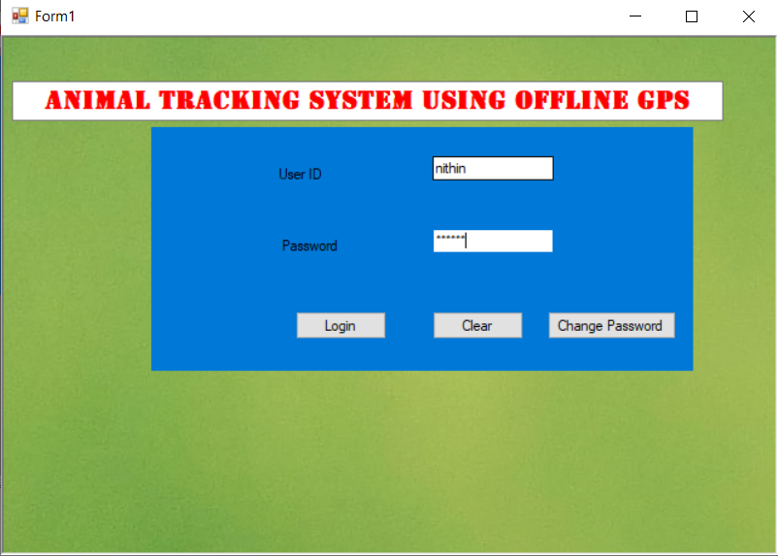

Figure 4.1: *Front page*

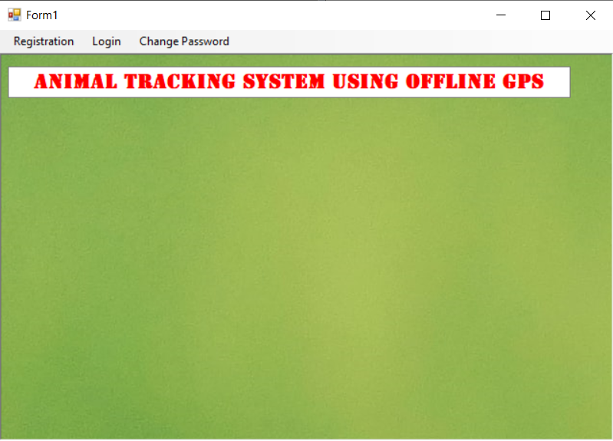

Figure 4.2: *Accessing page*

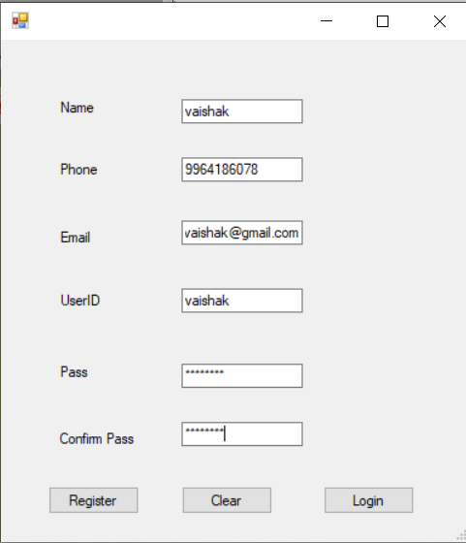

Figure 4.3: *Details feed-up page*

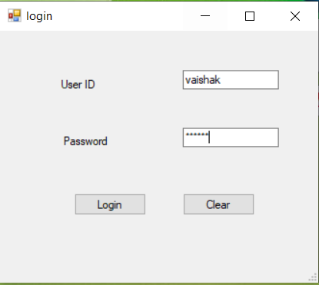

Figure 4.4: *login page*

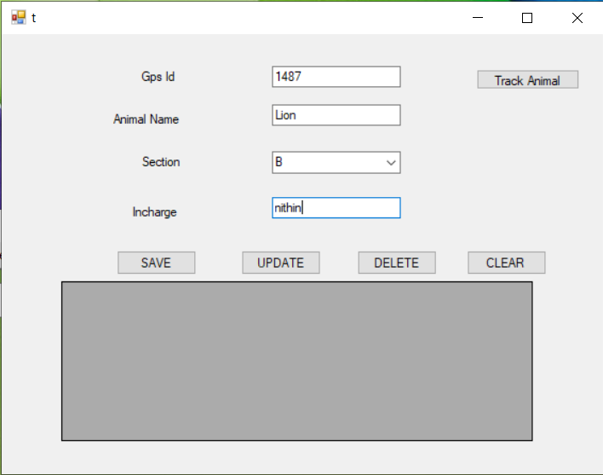

Figure 4.5*: Information page*

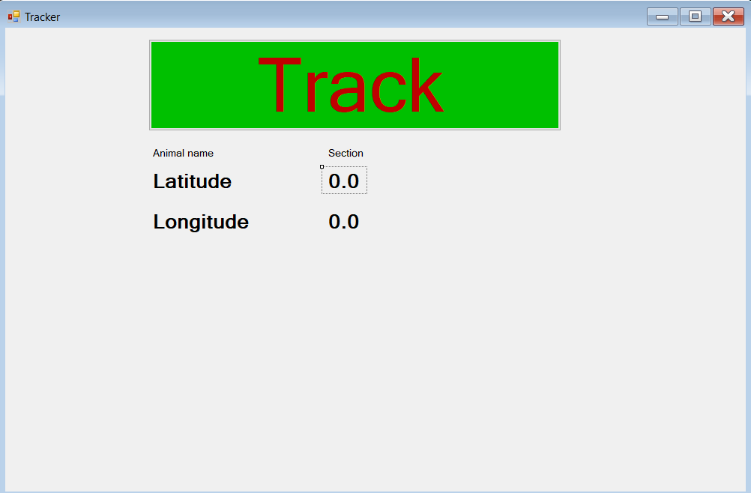

Figure 4.6: Tracker page

**4.2 Time Management**

The purpose of project time management is to ensure that the projects get completed on time. This knowledge area is primarily concerned with developing a project schedule and ensuring that the project goes as per the agreed schedule. Time management in the workplace has many positive effects. What we need to do is understand our role and responsibilities in our workplace. This will help us to begin and focus on our goals and achieve them efficiently. There will sometimes that we will be asked to do a lot of things at the same time. Unimportant tasks may take up time that we should be devoted to more important tasks. For that reason before accepting non-essential tasks we have to consider them and make a schedule. If we are focusing time and energy on really important tasks, it makes a more focused and valuable employee and reduces the stress of our work.

**4.3 Interpersonal Skills**

Development of the interpersonal skills of an employee is the key goal of training and development initiatives for many companies and it is considered a constructive manner in which to handle office disputes and other personnel issues. These skills include the areas of communications, listening, the delegation of tasks, and leadership.

Skills and knowledge in teamwork and communication are vital for the engineer. Teamwork is comprised of forming, operating, growing, and leading a team, along with some skills specific to technical teamwork.

Communications is composed of the skills necessary to devise a communications strategy and structure, and those necessary to use the four common media: written, oral, graphical, and electronic. Proficiency in a foreign language or languages is also a necessary and desired skill of the modern engineer.